FEDERAL STATE AUTONOMOUS EDUCATIONAL INSTITUTION OF HIGHER EDUCATION
ITMO UNIVERSITY

Course Project
Kinopoisk Data Analysis

Performed by
Boyi Li
Dutao Zhang
Muslimbek Abdurakhimov
Daan Rodríguez
Academic group
J4132c

St. Petersburg
2024
Kinopoisk is one of the largest and most popular entertainment platforms in Russia, founded in 2003. It offers an extensive database on movies, TV series, actors, and directors, including synopses, user and professional reviews, and ratings. It uses algorithms for personalized recommendations and provides showtime information. Acquired by Yandex in 2013, it has enhanced its services with advanced technology, becoming a reliable source of entertainment information in the country.

Goal:
Leverage Big Data technologies to extract meaningful insights from the collected data, which can be used to understand trends and patterns in the entertainment industry, specifically for Kinopoisk. This will facilitate better decision-making, enhance audience engagement, and drive innovation within the platform.

Objectives:
- Big Data Implementation:
  - Identify and Integrate Big Data Tools: Evaluate and select appropriate Big Data technologies (e.g., Hadoop, Spark, NoSQL databases) to build a robust data infrastructure tailored to Kinopoisk's needs.
  - Scalable Data Architecture: Design and implement a scalable data architecture capable of handling large volumes of structured and unstructured data from various entertainment sources.
  - Real-time Data Processing: Implement real-time data processing capabilities to provide timely insights and enhance the user experience on Kinopoisk.
- Data Gathering:
  - Data Source Identification: Identify and catalog various data sources including user reviews, streaming data, box office sales, and social media activity relevant to Kinopoisk.
  - Data Collection Framework: Develop a framework for continuous and automated data collection from identified sources to ensure comprehensive data coverage.
  - Data Quality Assurance: Implement robust data validation and cleaning procedures to maintain the accuracy and reliability of the collected data.
- Data Processing and Analysis:
  - Data Storage and Management: Establish efficient data storage solutions that support both batch and stream processing, optimizing for Kinopoisk's data needs.
  - Data Transformation: Implement ETL (Extract, Transform, Load) processes to prepare data for in-depth analysis.
  - Advanced Analytics: Apply advanced analytics techniques, including machine learning and statistical analysis, to uncover trends, patterns, and correlations in the entertainment industry data.
  - Visualization and Reporting: Develop interactive dashboards and reports to visualize insights, making them accessible and actionable for Kinopoisk stakeholders.

Selection of Big Data Technologies:

Technologies Used:
- Apache Spark: Used for distributed data processing to handle large volumes of data efficiently across multiple nodes.
- Pandas: Utilized for data cleaning and preprocessing, providing flexible data manipulation capabilities.

Challenges and Solutions:
- API Limits:
  - Challenge: API rate limits can restrict the amount of data that can be ingested in a given time frame, impacting data completeness.
  - Solution: Implementing a rate-limiting mechanism and using batching techniques to manage API requests efficiently. Additionally, leveraging asynchronous data fetching and caching intermediate results can mitigate the impact of rate limits.

Data Gathering:

Data Sources:
- Kinopoisk API: Data obtained through the Kinopoisk API, providing various attributes for each title.

Volume of Data Collected:
- Pages Collected: 21,145
- Rows of Data: Extracted data for approximately 34,300 movies
The data gathered includes a comprehensive set of attributes for each movie title, facilitating detailed analysis and insights into trends and patterns within the entertainment industry.
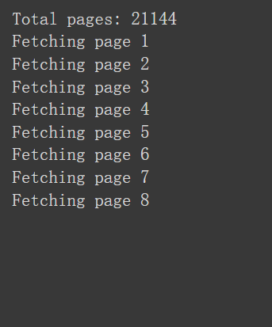
Figure 1. Data Gathering

Data Structure:
- Columns Include:
  - id: Unique identifier for each title.
  - name: Main title of the movie or series.
  - alternativeName: Alternative names for the title.
  - enName: English name of the title.
  - detailedDescription: In-depth description of the title.
  - shortDescription: Brief description of the title.
  - status: Current status of the title (e.g., released, upcoming).
  - ratings: Ratings received by the title.
  - voteCounts: Number of votes for the ratings.
  - duration: Duration of the movie or series.
  - ageRatings: Age ratings assigned to the title.
  - isSeries: Indicator if the title is a series.
  - ticketsOnSale: Indicator if tickets are currently on sale.
The comprehensive data set allows for detailed analysis and insights into various characteristics and popularity trends of movies and series. This information is crucial for understanding audience preferences, market trends, and the overall performance of titles on Kinopoisk.

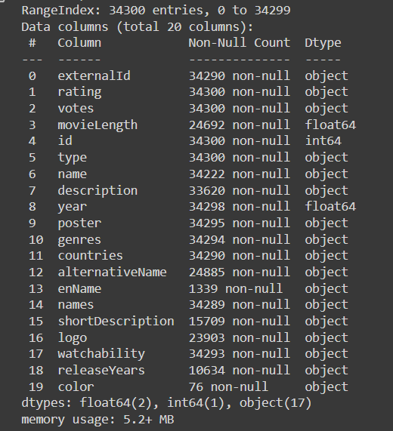
Figure 2. Data Structure

Data Processing and Analysis:

Goals of Data Processing and Analysis:
- Extract Insights: Derive meaningful insights from the data to understand trends and patterns in the entertainment industry.
- Improve Decision Making: Provide data-driven insights to support better decision-making processes.
- Enhance Data Quality: Ensure the data is clean, accurate, and reliable for analysis.

Steps of Data Processing:
- Data Cleaning and Preprocessing:
  - Remove Duplicates: Identify and remove duplicate entries to maintain data integrity.
  - Handle Missing Values: Address missing data by imputation or removal, depending on the context.
  - Standardize Formats: Ensure consistency in data formats for dates, ratings, and other attributes.
  - Normalization: Normalize data to bring all attributes to a common scale without distorting differences in the ranges of values.
- Data Transformation and Aggregation:
  - Transformation: Convert raw data into a suitable format for analysis, including parsing dates, converting categorical data, and encoding text data.
  - Aggregation: Summarize data to provide higher-level insights, such as calculating average ratings, total vote counts, and duration summaries for movies and series.
By following these steps, the data processing and analysis aim to extract valuable insights, support informed decision-making, and enhance the overall quality of the data used for analysis.

Data Scrapping
In the web crawling function, we employ 10 parallel processes to efficiently crawl 21,145 pages, processing 50 pages simultaneously. This parallel method enhances the speed and efficiency of data collection compared to sequential approaches. Each process works concurrently, significantly reducing the total time required for completion. Data is updated in real-time during each capture, ensuring access to the most current and accurate information, vital for real-time analysis. Validation and cleaning mechanisms are implemented at every stage to maintain data integrity, correcting any anomalies before storage. Additionally, a robust error-handling strategy ensures continuous operation despite any individual process failures. This system is crucial for maintaining high-quality data, essential for informed decision-making.

Defining JSON Schema for Spark
The “define_schema” function defines a detailed schema (structure) used to describe each field and its data type in the JSON file. This function specifies the exact format and constraints for each attribute, including data types such as integers, strings, dates, and more complex structures like arrays or nested objects. This precise definition ensures that, when loading JSON data, the Spark DataFrame correctly interprets and parses each field according to its intended format. Consequently, this facilitates accurate data processing, validation, and analysis, minimizing errors and inconsistencies in the dataset.

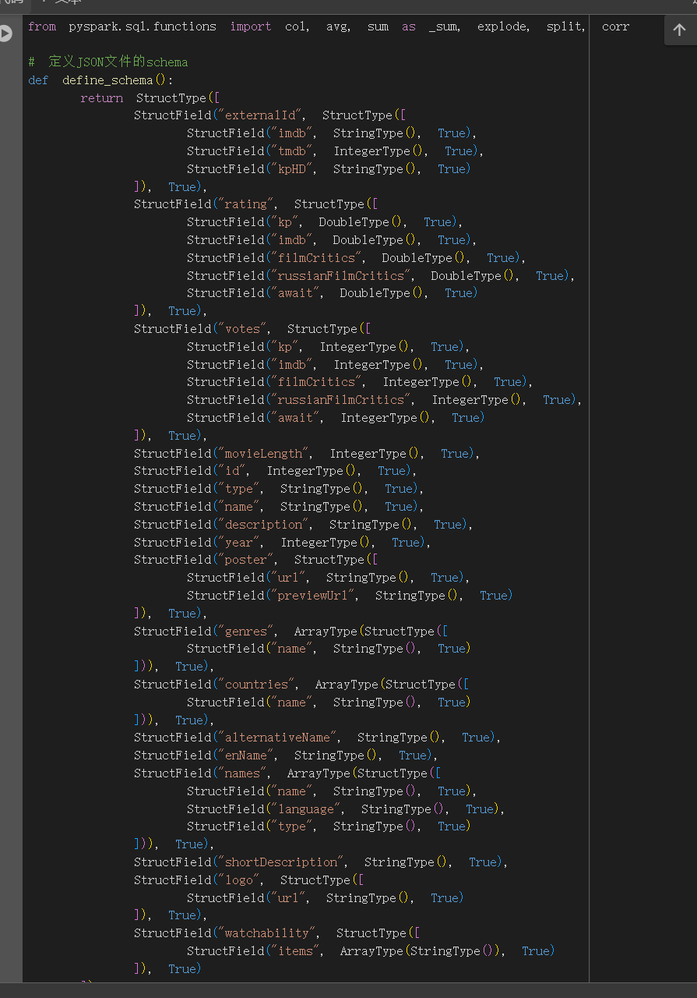
Figure 4. JSON Schema for Spark

Visualizations

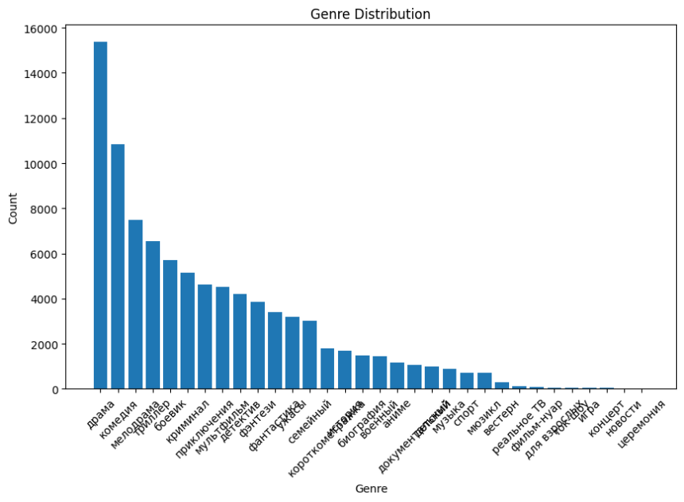
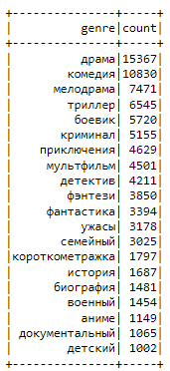
Figure 4. Genre Distribution
In Figure 4, the genre distribution of movies and series on Kinopoisk is shown. On the left, there is a table listing the genres in Russian along with the number of titles in each genre. On the right, a bar chart visualizes this data, with genres on the x-axis and the count of titles on the y-axis.
The analysis reveals that the most common genres are "драма" (drama) and "комедия" (comedy), followed by "мелодрама" (melodrama), "триллер" (thriller), and "боевик" (action). The less frequent genres include "аниме" (anime), "документальный" (documentary), and "детский" (children's).
This visualization allows for a quick understanding of which genres are most prevalent on the Kinopoisk platform, facilitating the analysis of user preferences and content trends.
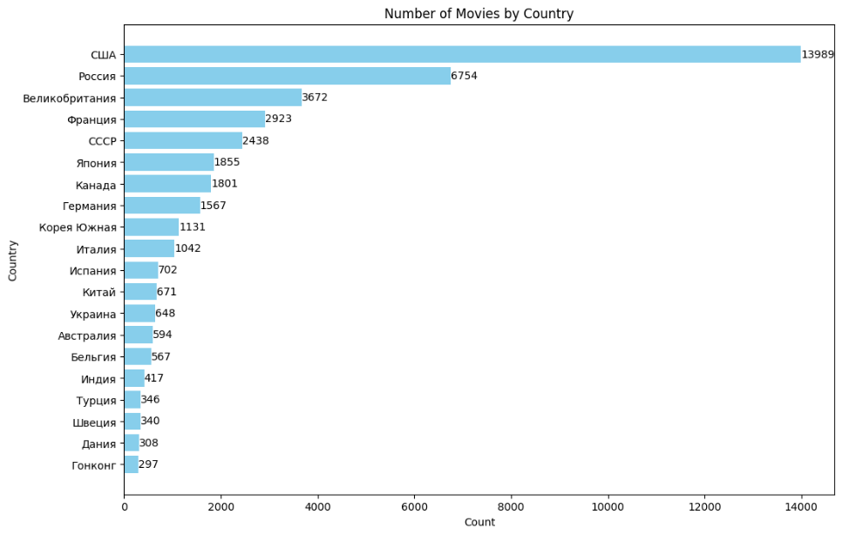
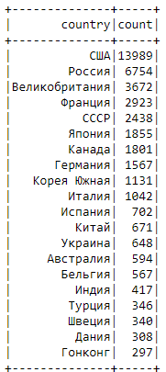
Figure 5. Number of Movies by Country
In Figure 5, the distribution of the number of movies by country on the Kinopoisk platform is shown. On the left, there is a table listing the countries in Russian along with the number of movies produced in each country. On the right, a bar chart visualizes this data, with countries on the y-axis and the movie count on the x-axis.
The analysis reveals that the country with the highest number of movies is "США" (USA), followed by "Россия" (Russia). Other countries with significant movie production include "Великобритания" (United Kingdom), "Франция" (France), and "СССР" (Soviet Union).
This visualization allows for a quick understanding of the geographical distribution of movie production on Kinopoisk, facilitating the analysis of production trends by country and content preferences based on the region.
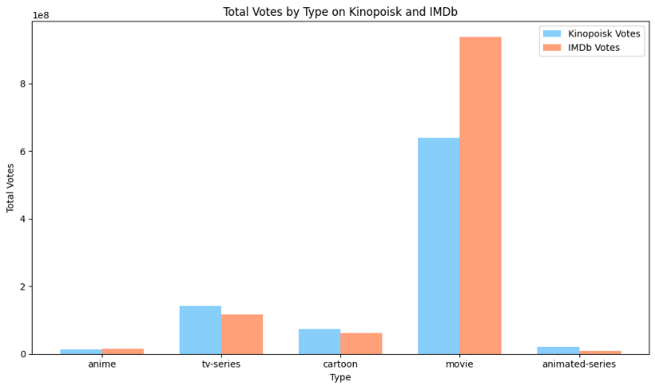
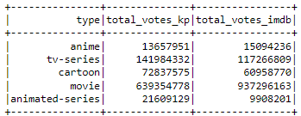

Figure 6. Total Votes by Type

In Figure 6, the total votes by type on Kinopoisk and IMDb are displayed. On the left, there is a table listing different types of content along with the total votes they received on both platforms. On the right, a bar chart visualizes this data, with content types on the x-axis and the total votes on the y-axis. The chart uses different colors to distinguish between votes on Kinopoisk (blue) and IMDb (orange).
The analysis reveals that "movie" has the highest total votes on both Kinopoisk and IMDb, with IMDb having a significantly higher count. "TV-series" also shows a high number of votes on both platforms, though with a relatively closer count between the two. Other content types like "cartoon," "animated-series," and "anime" have fewer votes in comparison.
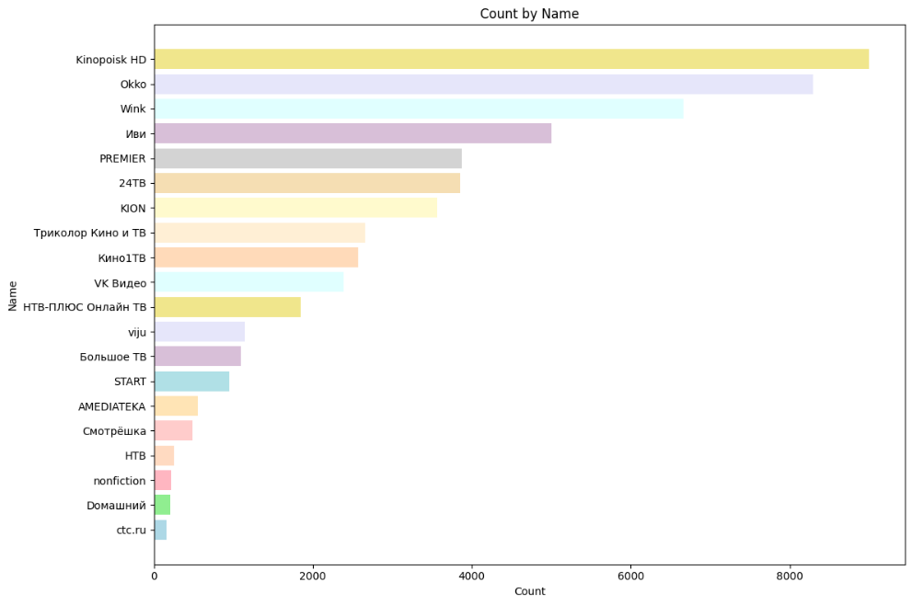
This visualization allows for a quick understanding of the voting distribution across different types of content on Kinopoisk and IMDb, facilitating the analysis of user engagement and popularity of content types on each platform.
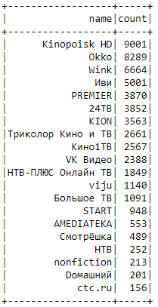 Figure 7. Count by Platform
In Figure 7, the count of titles by platform in the Kinopoisk database is shown. On the left, there is a table listing the platforms along with the number of titles available on each one. On the right, a bar chart visualizes this data, with the platforms on the y-axis and the title count on the x-axis.
The analysis reveals that "Kinopoisk HD" has the highest number of titles, followed by "Okko" and "Wink". Other platforms with a significant number of titles include "Иви" (Ivi), "PREMIER", and "24ТВ". Platforms with fewer titles include "Смотрёшка" (Smotreshka), "НТВ" (NTV), and "ctc.ru".
This visualization allows for a quick understanding of the distribution of content by platform on Kinopoisk, facilitating the analysis of title availability on each platform and helping to identify which platforms have the most content.

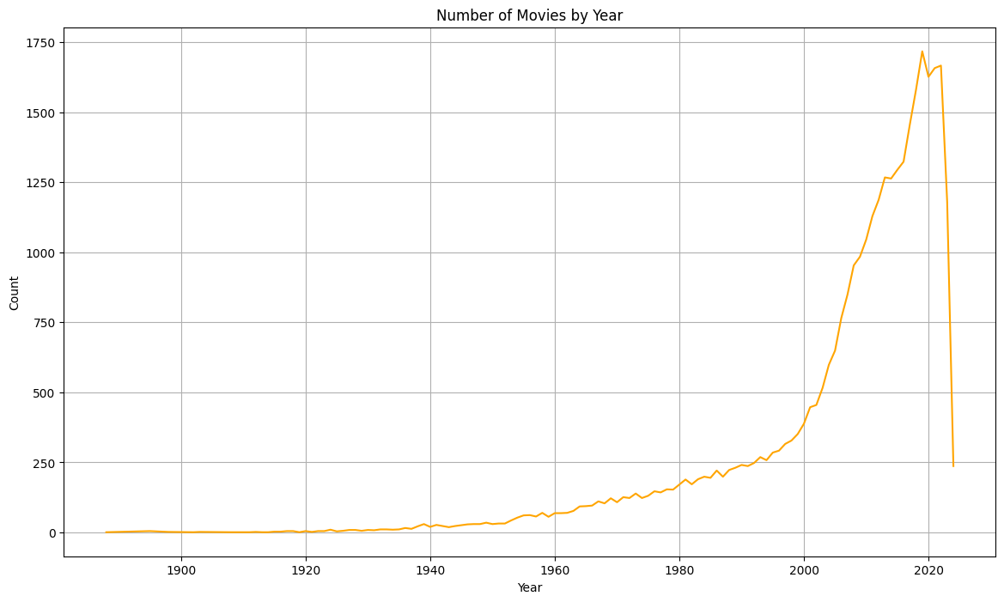
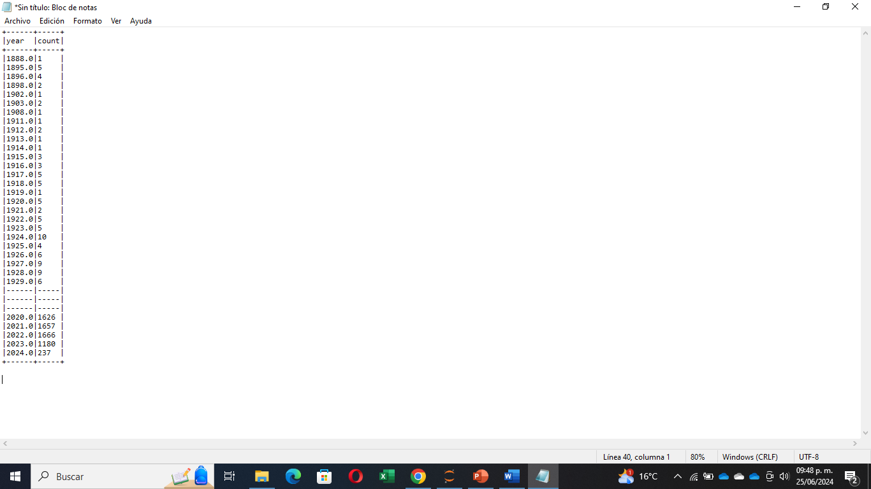
Figure 8. Number of Movies by Year
In Figure 8, the number of movies by year in the Kinopoisk database is shown. On the left, there is a table listing the years along with the number of movies produced in each year. On the right, a line chart visualizes this data, with the years on the x-axis and the movie count on the y-axis.
The analysis reveals a gradual increase in the number of movies produced from the late 19th century to the present, with notable growth starting in the 1960s. This growth accelerates significantly in the 1990s and 2000s, peaking in 2020 with 1,626 movies. The number of movies decreases in 2023 and 2024, which could be due to incomplete data or an actual decline in production.
This visualization allows for a quick understanding of movie production trends over time, facilitating the historical analysis of the film industry and helping to identify periods of significant increase in movie production.
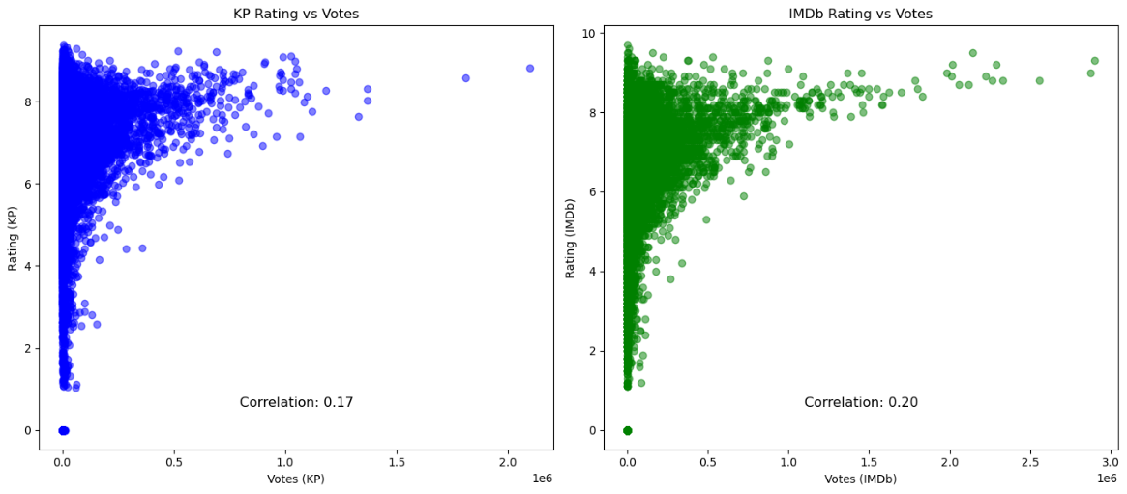
Figure 9. Correlation between Ratings and Votes
In Figure 9, two scatter plots compare the relationship between ratings and the number of votes on Kinopoisk and IMDb. The left plot shows the relationship for Kinopoisk, with the x-axis representing the number of votes and the y-axis representing the ratings. The right plot shows the same relationship for IMDb.
- Kinopoisk (Left Plot):
  - The scatter plot shows a wide distribution of ratings across different vote counts.
  - There is a noticeable concentration of data points around higher ratings (6-8) with varying numbers of votes.
  - The correlation coefficient of 0.17 indicates a weak positive correlation between the number of votes and the ratings on Kinopoisk.
- IMDb (Right Plot):
  - Similar to Kinopoisk, the scatter plot shows a wide distribution of ratings across different vote counts.
  - There is a dense cluster of data points around ratings of 6 to 8, with a high number of votes.
  - The correlation coefficient of 0.20 indicates a slightly stronger, yet still weak, positive correlation between the number of votes and the ratings on IMDb compared to Kinopoisk.
These scatter plots illustrate that while there is a slight positive correlation between the number of votes and ratings on both Kinopoisk and IMDb, the relationship is relatively weak. This suggests that higher ratings do not necessarily correlate with a higher number of votes. The visualization helps to understand the distribution and correlation of user ratings and votes on both platforms.

Real-Time Queries with Flask and Spark
Finally, we use Flask to integrate Spark into an interactive web page. This allows users to perform quick real-time queries simply by clicking on different functions available on the interface. The combination of Flask and Spark facilitates the management and visualization of large volumes of data, enhancing the user experience by providing instant results and intuitive interaction. This integration not only makes data more accessible but also allows for the customization and extension of the web application according to the specific needs of the users.
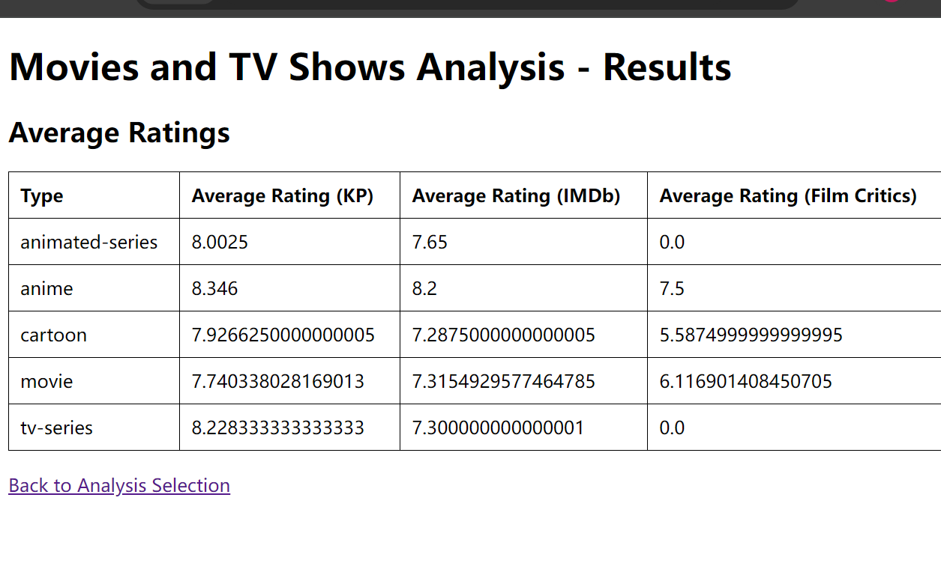
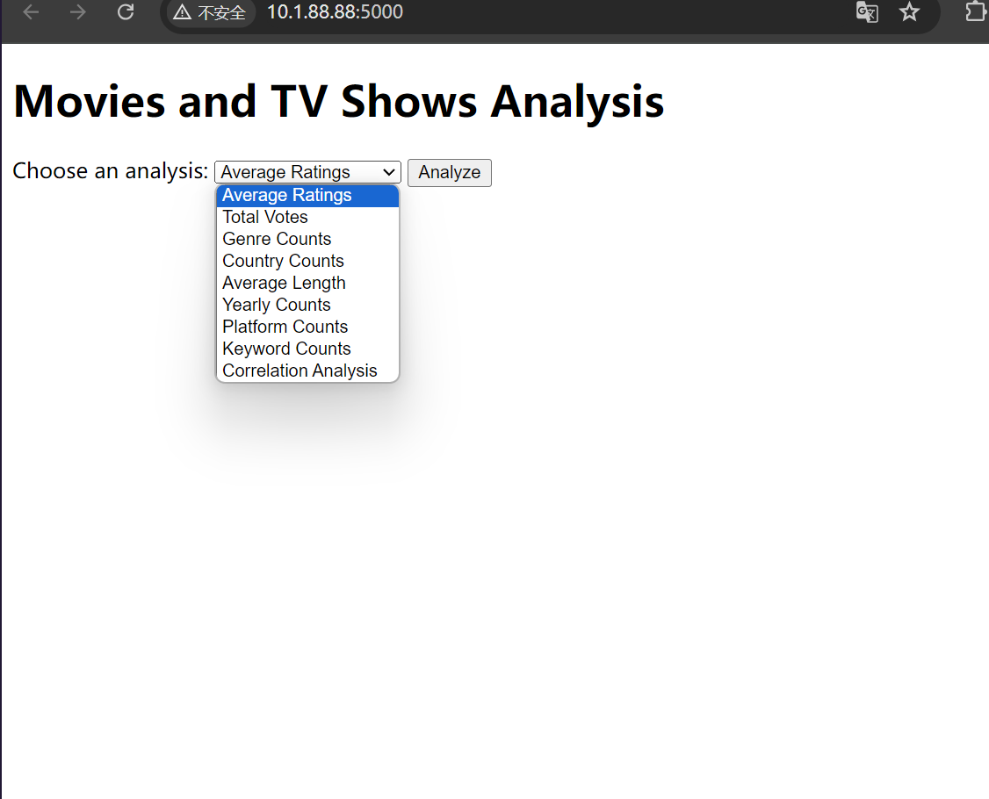

Figure 10. Real-Time Queries

Conclusion
We successfully gathered a comprehensive dataset from Kinopoisk via their API, which includes various attributes like titles, genres, release dates, and ratings. This dataset lays a strong foundation for in-depth analysis.
By implementing Apache Spark, we enhanced the efficiency of data processing and storage, taking advantage of its distributed capabilities to manage large data volumes swiftly and effectively, thereby reducing processing times significantly.
Through various analytical methods, we derived insights into audience preferences and market trends, identifying popular genres and shifts in content demand.
We also set up real-time data processing, crucial for providing current insights and supporting agile decision-making, allowing us to rapidly adapt to changes in viewing habits and emerging trends within the entertainment industry.
Overall, our use of data from Kinopoisk combined with Apache Spark has enabled us to handle large datasets efficiently and glean critical insights for real-time market response.

